**Graphs**

1. Consider the following graph and find the following:
2. The degree of each vertex

Deg(a) = 1, deg(b) = 3, deg(c) = 3, deg(d) = 2, deg(e) = 4, def(f) = 2, deg(g) = 3, deg(h) = 2

1. Make an adjacency list for each vertex

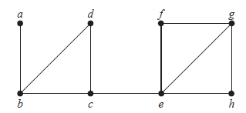

|  |  |
| --- | --- |
| Vertices | Adjacent Vertices |
| A | B |
| B | A,c,d |
| C | B,d |
| D | B,c |
| E | F,c,h,g |
| F | G,e |
| G | F,e,h |
| H | G,e |

1. Determine whether the following graphs are isomorphic or not.

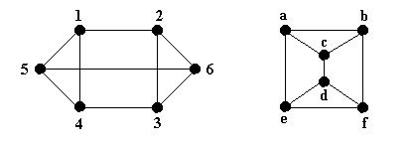

|  |  |
| --- | --- |
| **G1** | **G2** |
| No. of vertices = 6 | No of vertices = 6 |
| No. of edges = 9 | No. of edges = 9 |
| Deg(1) = 3, deg (2) = deg(3) = 3, deg (4) = 3, deg (5) = 3, deg (6) = 3 | Deg(a) = 3, deg (b) = deg(c) = 3, deg (d) = 3, deg (e) = 3, deg (f) = 3 |

**Mapping:** f(1) = a, f(2) = e, f(3) = f, f(4) = b, f(5) = c, f(6) = d

**The graphs are isomorphic**

1. Consider the following graph and find the following:
2. Adjacency matrix
$$\begin{matrix} & u_{1} & u_{2} & u_{3} & u_{4} & u_{5} & u_{6} \\ u_{1} & 0 & 0 & 0 & 1 & 0 & 0 \\ u_{2} & 0 & 0 & 0 & 0 & 1 & 0 \\ u_{3} & 0 & 0 & 0 & 1 & 0 & 1 \\ u_{4} & 0 & 1 & 0 & 0 & 0 & 0 \\ u_{5} & 1 & 0 & 1 & 0 & 0 & 0 \\ u_{6} & 1 & 1 & 0 & 0 & 0 & 0\end{matrix}$$

3. In-degree and out-degree for each vertex

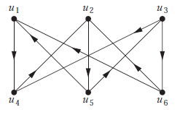

In degrees of

$$u_{1}=2, u_{2}=2, u_{3}=1, u_{4}=2, u_{5}=1, u_{6}=1$$

out degrees of

$$u_{1}=1, u_{2}=1, u_{3}=2, u_{4}=1, u_{5}=2, u_{6}=2$$

1. Consider the following graph and find:
2. A Eular path or circuit if there is any
3. A Hamilton path or circuit if there is any

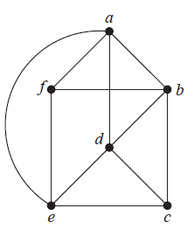

1. An Euler path exists i.e “f b c e f a d b a e d c”
2. Hamilton path: f a b d e c

Hamilton Circuit: a b f e c d a

1. A full 5-ary tree has 501 vertices. Find the number of leaves and internal vertices.
$$No. of vertices=n=501$$

$$internal vertices=i= \frac{n-1}{m}=100$$

$$no. of leaves=l=\frac{\left(m-1\right)n+1}{m}=401$$

2. Span the following graph by removing the circuits

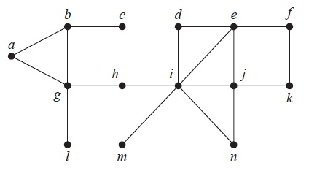

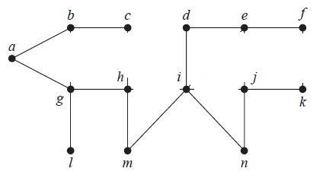

1. Start from vertex **d,** span the following graph using breadth-first search algorithm.

